**ECE 254 Homework 4**

**Rayleigh Fading Signal**

**Name: Mingxuan Wang**

**Date: 2015/11/6**

* Title: Rayleigh Fading Signal
* Objective:

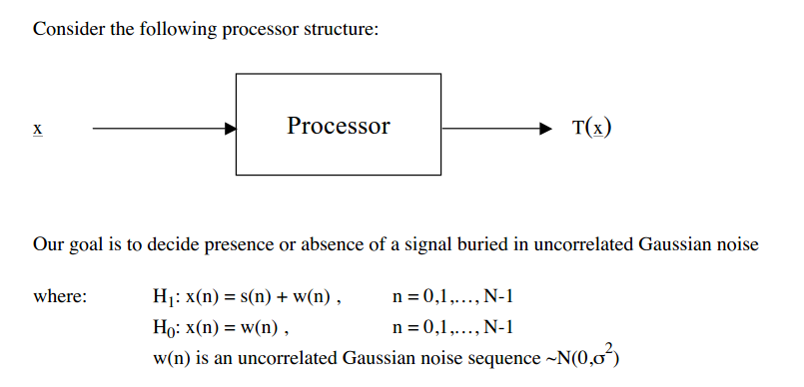

1. Consider three different classes of signals:

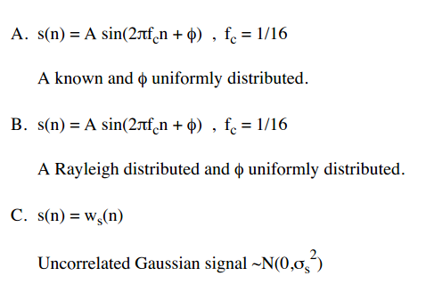

1. Summarize briefly the analytical derivation of the test statistic and performance for the following optimum detection receivers:

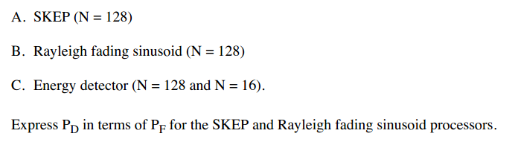

1. Plot the performance of the processors in II above as:

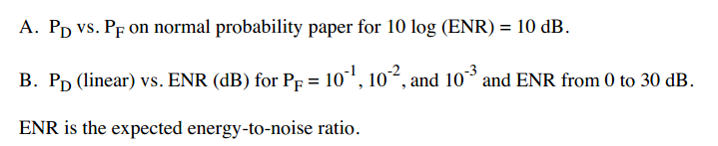

* Approach:

See handwriting.

* Results(including plots):



**Figure 1 PD vs PF on normal probability paper for ENR = 10**



**Figure 2 PD vs ENR for PF = 10^-1, 10^-2, 10^-3 with SKEP**



**Figure 3 PD vs ENR for PF = 10^-1, 10^-2, 10^-3 with Rayleigh fading sinusoid**



**Figure 4 PD vs ENR for PF = 10^-1, 10^-2, 10^-3 with Energy Detector and N = 128**



**Figure 5 PD vs ENR for PF = 10^-1, 10^-2, 10^-3 with Energy Detector and N = 16**

**Discussion:**

1. For figure 1, we can see that:
   1. SKEP performs the best for all time.
   2. Before around pf = 0.46, Rayleigh fading sinusoid performs the second and Energy Detector with N = 16 is the third.
   3. After around pf = 0.46, Energy Detector with N = 16 performs the second and Rayleigh fading sinusoid is the third.
   4. Energy Detector with N = 128 perform the worst.
   5. According to the formula derived in Approach part, we can see that for Energy Detector, with the increasing the N, the SNR is becoming less and less. This is what we see in figure 2 – N=16 condition is better than N = 128.
2. For figure2 – figure4:
   1. With the decrease of pf, the curve (pd vs ENR) turn to right a little bit each time.
   2. With the decrease of pf, the slope of the curve becomes steeper.
   3. With the increase of ENR, the performance becomes better.
   4. The slope of the curve in Rayleigh fading sinusoid is smaller than others. To obtains a certain pd, the ENR of Rayleigh fading sinusoid is bigger than others.
   5. We can still find that with the increasing of N, the performance of Energy Detector is worse.

* Appendix:

Hw4.m

%% SKEP with fixed ENR

clear;clc;

ENR = 10;

lambda = ENR;

pf1 = 0.01:0.01:1;

x1 = -2*log(pf1);

pd1 = Qchipr2(2, lambda, x1, 1e-5);

figure(1)

probpaper(pf1,pd1, 'r');

%% Rayleigh fading sinusoid with fixed ENR

pf2=0.01:0.01:1;

pd2=pf2.^(1/(1+ENR/2));

figure(1)

hold on

probpaper(pf2,pd2, 'b')

%% Energy detector with fixed ENR

% N = 128

N1=128;

pf3=0.01:0.01:1;

pd3=zeros(1,100);

for i=1:100

r1=getgama(pf3(i),N1);

R1=2*r1;

gama1=R1/(ENR/N1+1);

pd3(i)=Qchipr2(N1,0,gama1,1e-5);

end

figure(1)

hold on

probpaper(pf3,pd3, 'y')

% N = 16

N2=16;

pf4=0.01:0.01:1;

grid

r2=getgama(pf4,N2);

R2=2*r2;

gama2=R2/(ENR/N2+1);

pd4=Qchipr2(N2,0,gama2,1e-5);

figure(1)

probpaper(pf4,pd4, 'c')

legend('SKEP', 'Rayleigh fading sinusoid', 'Energy detector with N = 128', 'Energy detector with N = 16');

%% 3B SKEP

pf1 = 10^-1;

pf2 = 10^-2;

pf3 = 10^-3;

ENR=0:0.5:30;

lambda=10.^(ENR/10);

x1=2*log(1/pf1);

x2=2*log(1/pf2);

x3=2*log(1/pf3);

pd1=zeros(1,61);

pd2=zeros(1,61);

pd3=zeros(1,61);

for i=1:61

pd1(i)=Qchipr2(2,lambda(i),x1,1e-5);

pd2(i)=Qchipr2(2,lambda(i),x2,1e-5);

pd3(i)=Qchipr2(2,lambda(i),x3,1e-5);

end

figure(2)

plot(ENR,pd1,'b')

hold on

plot(ENR,pd2,'y')

plot(ENR,pd3,'r')

grid;

title('PD (linear) vs. ENR (dB) for PF = 10-1, 10-2, and 10-3 with SKEP.');

legend('pf=10^-1','pf=10^-2','pf=10^-3');

%% Rayleigh

x=10.^(ENR/10);

y=1./(x/2+1);

pd4=pf1.^y;

pd5=pf2.^y;

pd6=pf3.^y;

figure(3)

plot(ENR,pd4,'b')

hold on

plot(ENR,pd5,'y')

plot(ENR,pd6,'r')

grid;

title('PD (linear) vs. ENR (dB) for PF = 10-1, 10-2, and 10-3 with Rayleigh fading sinusoid.');

legend('pf=10^-1','pf=10^-2','pf=10^-3');

%% Energy Detector

%N=128

N1=128;

pd7=zeros(1,61);

pd8=zeros(1,61);

pd9=zeros(1,61);

r7=getgama(pf1,N1);

R7=2*r7;

r8=getgama(pf2,N1);

R8=2*r8;

r9=getgama(pf3,N1);

R9=2*r9;

for i=1:61

gama7=R7/(x(i)/N1+1);

pd7(i)=Qchipr2(N1,0,gama7,1e-5);

gama8=R8/(x(i)/N1+1);

pd8(i)=Qchipr2(N1,0,gama8,1e-5);

gama9=R9/(x(i)/N1+1);

pd9(i)=Qchipr2(N1,0,gama9,1e-5);

end

figure(4)

plot(ENR,pd7,'b')

hold on

plot(ENR,pd8,'y')

plot(ENR,pd9,'r')

axis([0 30 0 1])

grid;

title('PD (linear) vs. ENR (dB) for PF = 10-1, 10-2, and 10-3 with Energy Detecor and N = 128.');

legend('pf=10^-1','pf=10^-2','pf=10^-3');

% N= 16

N2=16;

pd10=zeros(1,61);

pd11=zeros(1,61);

pd12=zeros(1,61);

r10=getgama(pf1,N2);

R10=2*r10;

r11=getgama(pf2,N2);

R11=2*r11;

r12=getgama(pf3,N2);

R12=2*r12;

for i=1:61

gama10=R10/(x(i)/N2+1);

pd10(i)=Qchipr2(N2,0,gama10,1e-5);

gama11=R11/(x(i)/N2+1);

pd11(i)=Qchipr2(N2,0,gama11,1e-5);

gama12=R12/(x(i)/N2+1);

pd12(i)=Qchipr2(N2,0,gama12,1e-5);

end

figure(5)

plot(ENR,pd10,'b')

hold on

plot(ENR,pd11,'y')

plot(ENR,pd12,'r')

grid;

title('PD (linear) vs. ENR (dB) for PF = 10-1, 10-2, and 10-3 with Energy Detector and N = 16.');

legend('pf=10^-1','pf=10^-2','pf=10^-3');

getgama.m

function y=getgama(PFA,N)

x1=1;

x2=0;

while(abs(x1-x2)>1e-9)

x2=x1;

x1=iteration(PFA,x1,N);

end

y=x1;

end

function y=iteration(PFA,r,N)

s=0;

for i=1:(N/2)-1

s=s+(r.^i)/factorial(i);

end

y=-log(PFA)+log(1+s);

end